Journey starts from here in UAM.
First create system: Integration Management enables the configuration and maintenance of system mappings, registries, and connections that support the secure exchange of data and services across internal and external platforms.
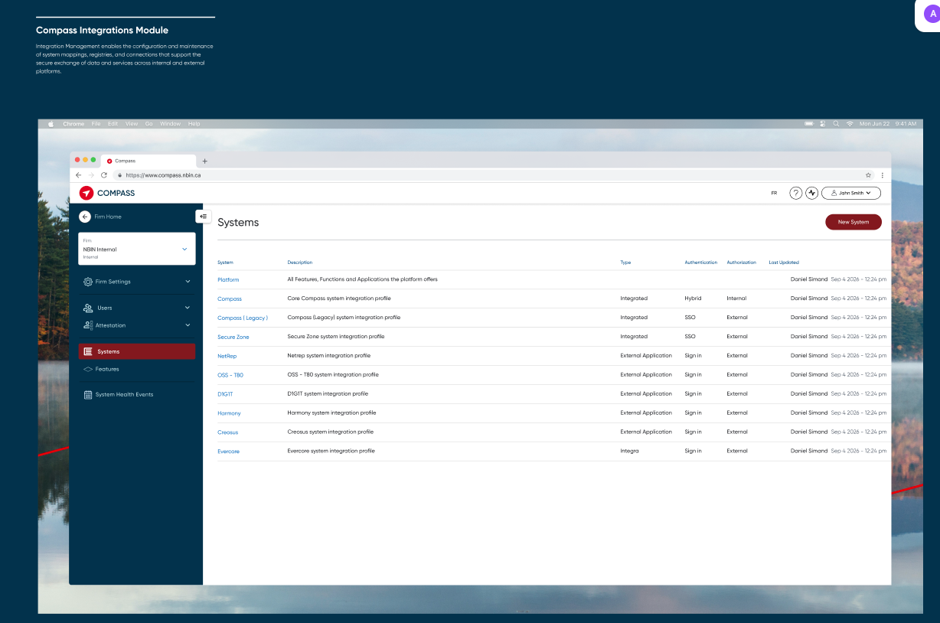

Next: Platform Integration Specification: Anchor Platform (Compass)
The Compass Platform Integration serves as the authoritative system definition for the Compass ecosystem. Unlike other integrated systems, Compass acts as the anchor platform and therefore its core integration settings are system-defined and cannot be modified by administrators.
The purpose of this configuration is to expose the full inventory of assignable platform capabilities, modules, functions, and external applications that can be referenced by user profiles, access groups, entitlement models, and security administration workflows. While the configuration information is visible for transparency and governance purposes, the core platform definition remains read-only to preserve alignment with the underlying Compass platform architecture.

A list of the assignable features, functions and applications within the compass ecosystem. This is only one with all three, other integrated systems will only have functions.
Modules
Modules in compass comprise of all the integrations of features into the platform.
This includes both:
Native modules
External Modules
Functions
List of the assignable functions compass users can perform within the available features in compass.
Both the features assignable in compass as well as external systems should be listed in the compass integration page. This will allow compass to reflect a users full access inside compass.
External Applications
Applications offered to clients but not integrated into the platform
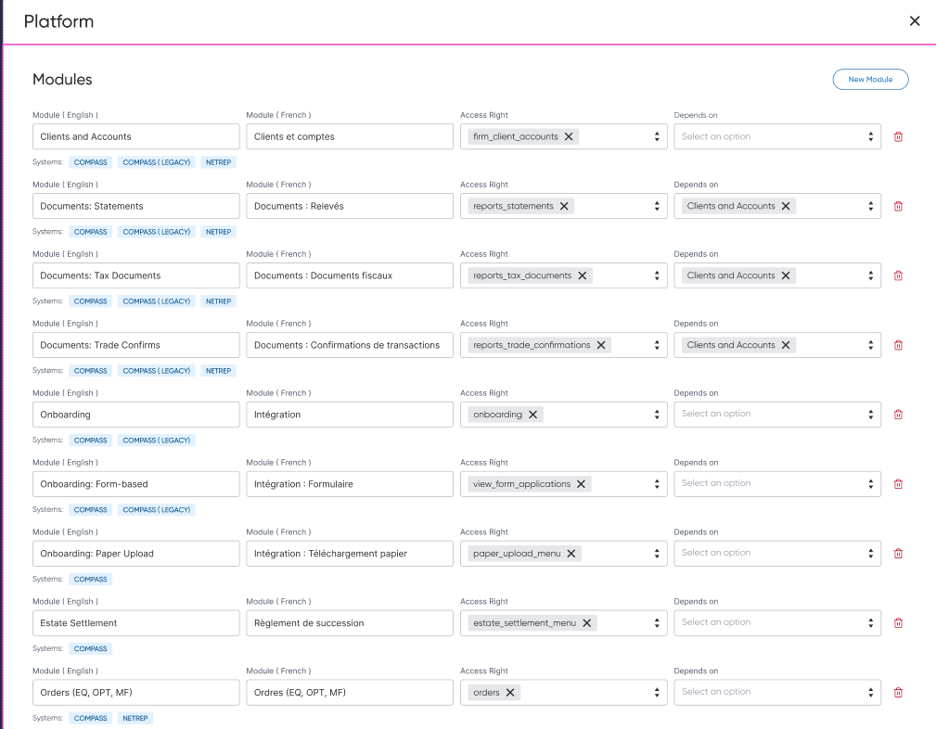
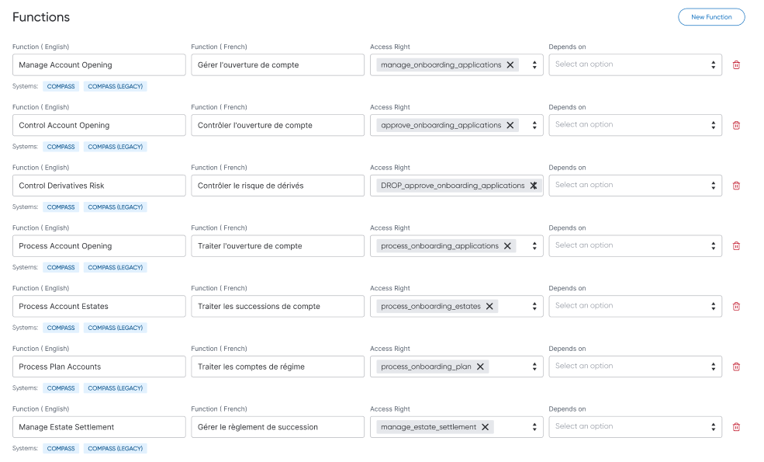
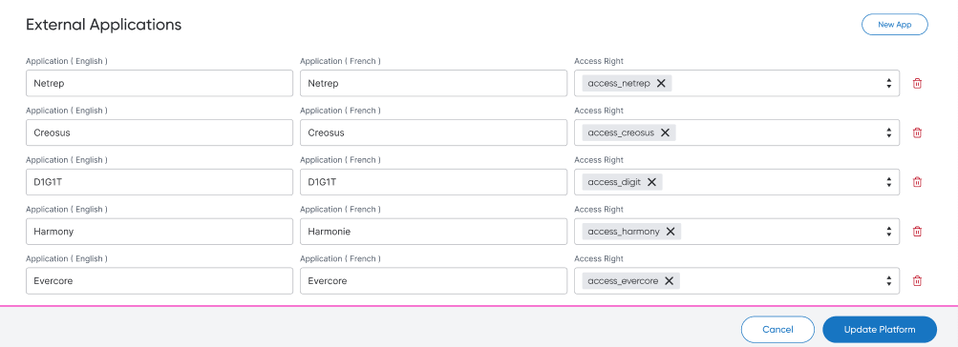
New integrated System:
Integration Mapping Configuration provides forms and tools to define, maintain, and validate mappings, registries, and data relationships between the platform and external systems to support seamless integration and data exchange.

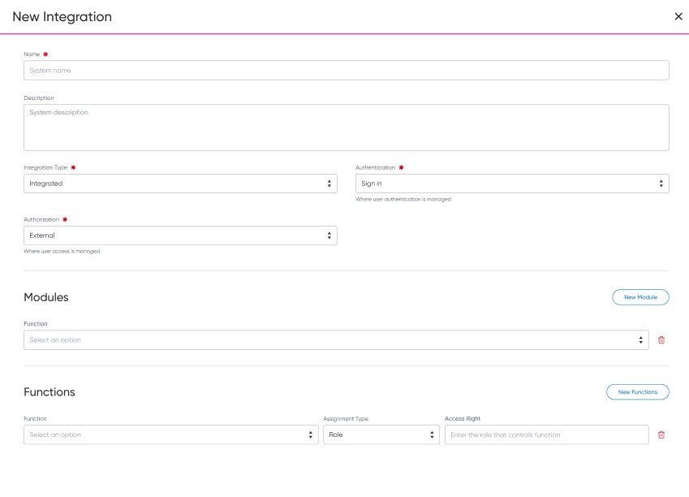
External system integration registry
The Integration Registry is a centralized configuration repository that maintains metadata, access management characteristics, and authorization mappings for all external systems integrated with the platform. Its purpose is to make the platform aware of how each integrated application authenticates users, manages user permissions, and receives entitlement assignments.
The registry serves as the authoritative source for determining:
How users access an integrated system
Where identity and access management responsibilities reside
Whether platform-driven provisioning is supported
How platform functions map to permissions, roles, or groups within external systems
What actions can be automated as part of user onboarding, maintenance, and deactivation workflows
By standardizing system characteristics, the platform can provide a consistent user administration experience while supporting systems with varying security and authorization models.

System Name: A unique business-friendly name for the integrated system. System Description: A description explaining the purpose of the integrated application and the capabilities it provides.
Authentication Source: Identifies where user authentication is managed.
SSO - Authentication is managed by the platform through SSO or a shared identity provider
Sign in - Authentication is managed directly by the destination application.
Hybrid - Both platform and application authentication mechanisms are supported.
Authorization Source: Determines where user permissions are managed.
Internal - Permission assignment is managed within the platform.
External - Permission assignment is managed directly in the target application.
Hybrid - Some permissions are assigned in-platform while others are managed externally.

The core purpose of the Integration Registry is to map platform business functions to external security assignments.
A single platform function may map to multiple external assignments.
Platform Function
Represents a business function ( permission or entitlement) recognized by the platform.
Examples:
Manage Clients
Manage Accounts
Manage Trading
Manage Reporting
Control Trading
Approve Transfers
If the authorization type is External, the following mapping helps to enable that feature in the external system.
Assignment Type
Specifies the security construct used by the external system.
Results in a list of instructions
Role - Access granted through application roles
Group - Access granted through security groups
Permission - Access granted through individual permissions
Entitlement - Access granted through entitlement objects
License - Access tied to a product license
Custom - Custom assignment structure
Assignment Value
The actual value that exists in the destination system.
Examples
Trading Administrator
Operations Supervisor
Onboarding Advisor
Reporting User
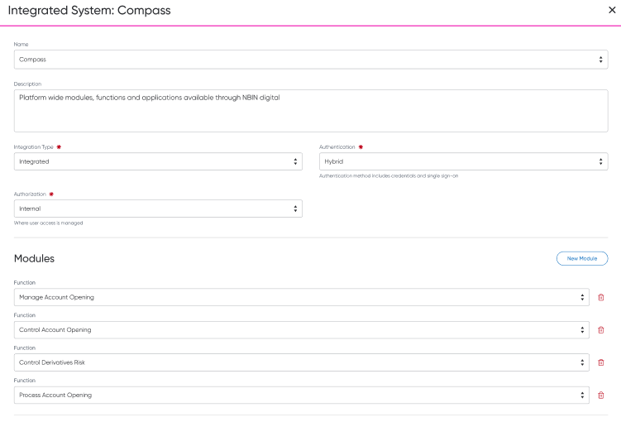
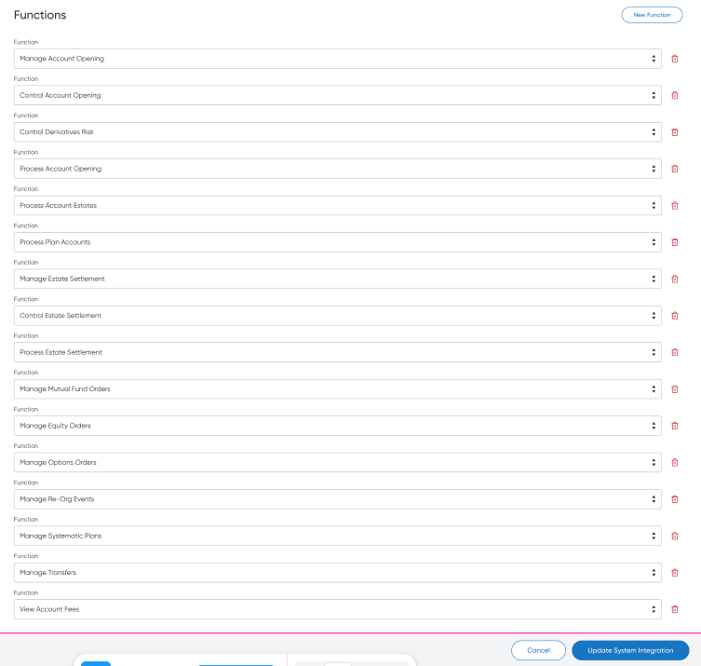
External system integration registry
The Integration Registry is a centralized configuration repository that maintains metadata, access management characteristics, and authorization mappings for all external systems integrated with the platform. Its purpose is to make the platform aware of how each integrated application authenticates users, manages user permissions, and receives entitlement assignments.
The registry serves as the authoritative source for determining:
How users access an integrated system
Where identity and access management responsibilities reside
Whether platform-driven provisioning is supported
How platform functions map to permissions, roles, or groups within external systems
What actions can be automated as part of user onboarding, maintenance, and deactivation workflows
By standardizing system characteristics, the platform can provide a consistent user administration experience while supporting systems with varying security and authorization models.
System Detailes:
System Identifier: Unique technical identifier used internally by the platform. System Name: A unique business-friendly name for the integrated system. System Description: A description explaining the purpose of the integrated application and the capabilities it provides.
Authentication Source: Identifies where user authentication is managed.
SSO - Authentication is managed by the platform through SSO or a shared identity provider
Platform Sign in - Authentication is managed directly by the destination application.
Hybrid - Both platform and application authentication mechanisms are supported.
External App - Not Connection with the platform
Authorization Source: Determines where user permissions are managed.
Internal Platform - Permission assignment is managed within the platform.
External App - Permission assignment is managed directly in the target application.
Hybrid - Some permissions are assigned in-platform while others are managed externally.
Function Assignment Mapping:
The core purpose of the Integration Registry is to map platform business functions to external security assignments.
A single platform function may map to multiple external assignments.
Platform Function
Represents a business capability recognized by the platform.
Examples:
Manage Clients
Manage Accounts
Manage Trading
Manage Reporting
Control Trading
Approve Transfers
Assignment Type
Specifies the security construct used by the external system.
Results in a list of instructions
Role - Access granted through application roles
Group - Access granted through security groups
Permission - Access granted through individual permissions
Entitlement - Access granted through entitlement objects
License - Access tied to a product license
Custom - Custom assignment structure
Assignment Value
The actual value that exists in the destination system.
Examples
Trading Administrator
Operations Supervisor
Onboarding Advisor
Reporting User
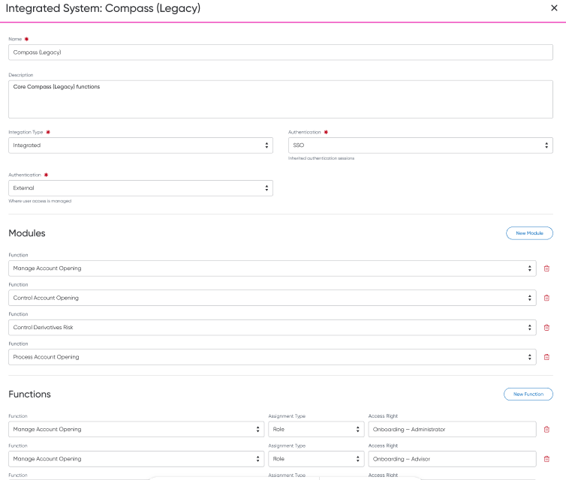
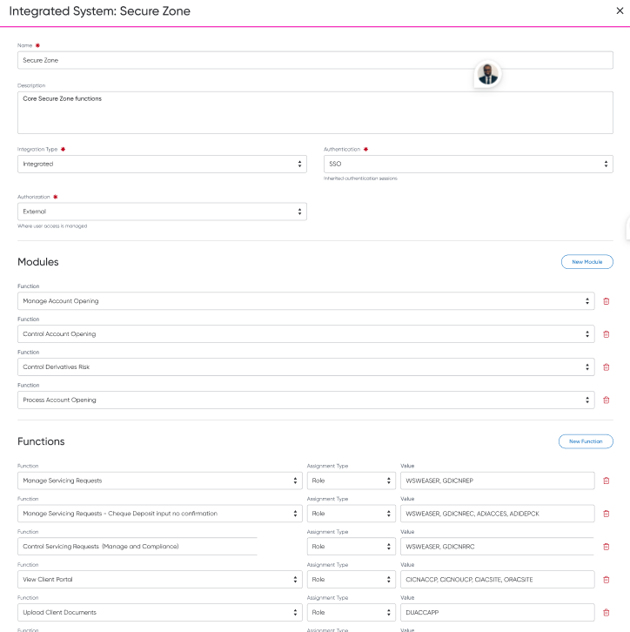
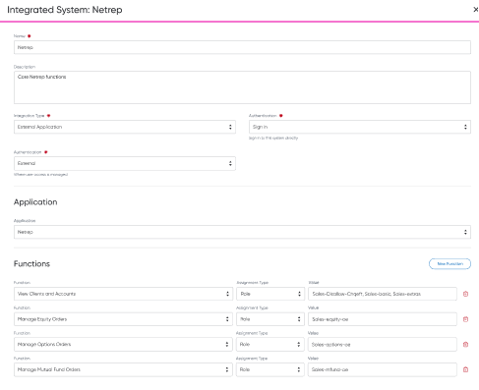
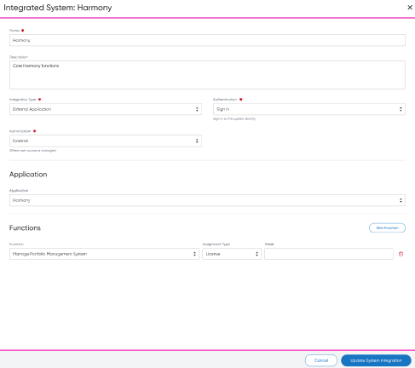
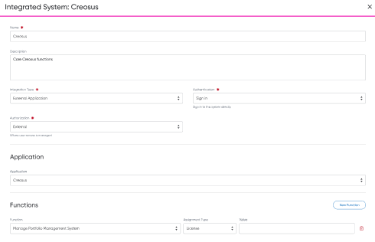
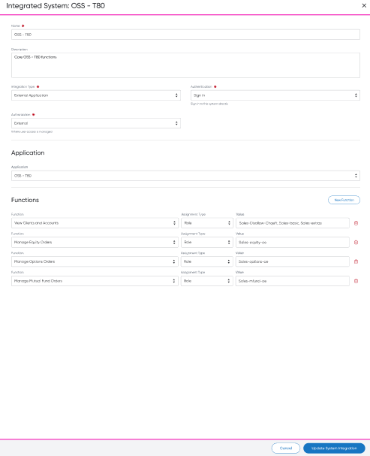
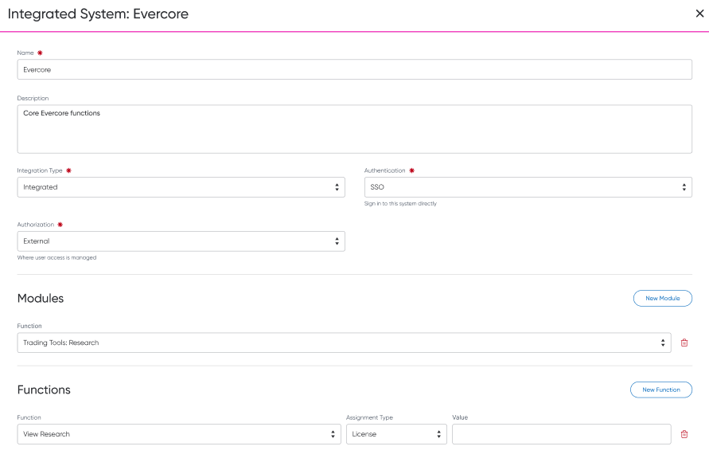
The Feature Management screen allows authorized platform administrators and product teams to define and maintain the catalogue of capabilities, features, modules, functions, and access packages offered through Compass.
The screen maintains the hierarchical relationship between:
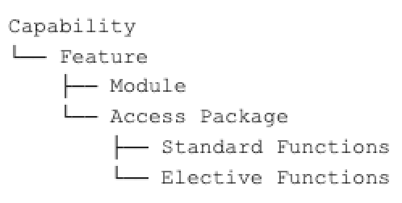
The Feature Management catalogue represents what Compass offers in consistent business terminology. It does not independently define the roles, permissions, profiles, groups, or technical resources used by each integrated system. Those values are maintained in the System Integration Registry and selected by reference when configuring a feature.
This separation allows Compass to present one consistent product and access model while supporting different implementation models across Compass, Compass Legacy, R2, Secure Zone, NetRep, and other integrated applications. The registry material describes that distinction as a mapping between Compass functions and the roles, permissions, groups, profiles, or other assignments used to provide the equivalent access in each system.
The purpose of Feature Management is to establish an authoritative, reusable directory of the services and functionality available through Compass.
The directory supports platform capabilities that need to understand:
What Compass offers.
How the offering is organized into business capabilities and features.
Which Compass modules provide access to each feature.
Which functions are included automatically with an access level.
Which functions can be assigned electively.
Which system-specific permissions implement the requested access.
Whether a feature is available for use by consuming platform services.
How a feature should be identified consistently across platform experiences.
The Feature Registry currently includes product hierarchy, status, module, module resource, system, access-package grouping, and View, Manage, Control, and Process assignments.
After creating integration by Adminsitrator team, then the same team should configure features here:
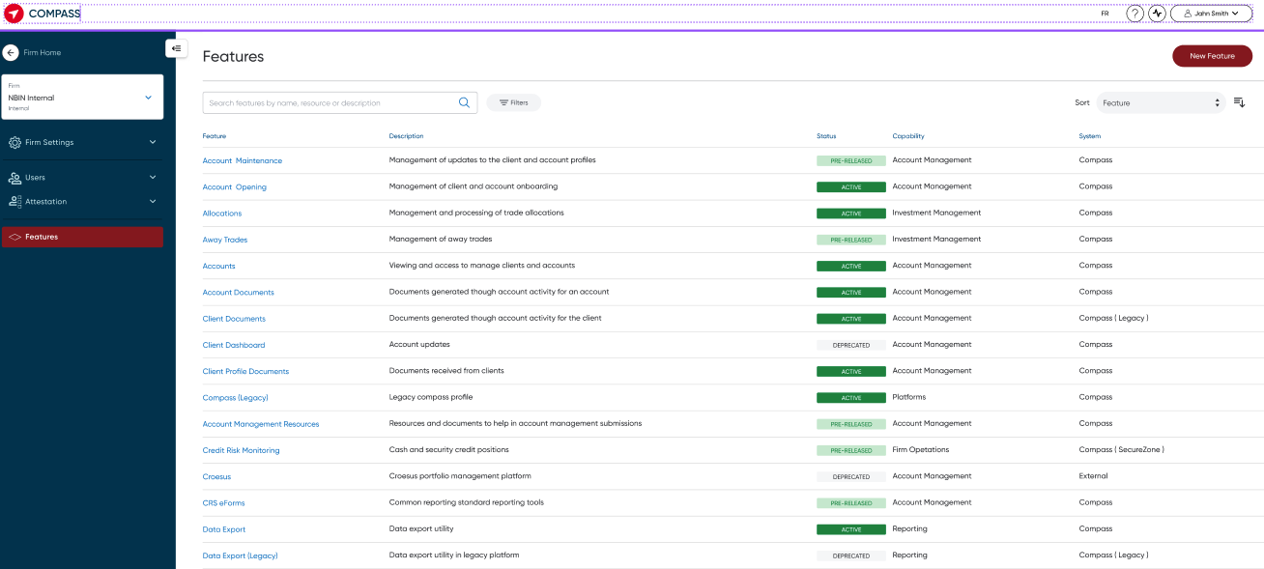
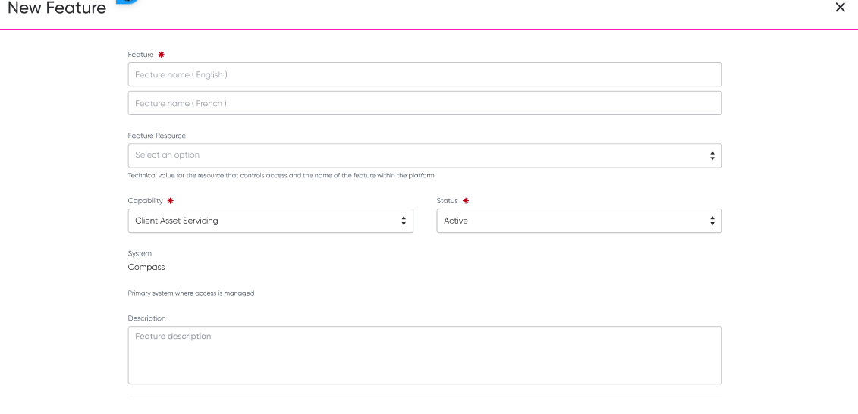
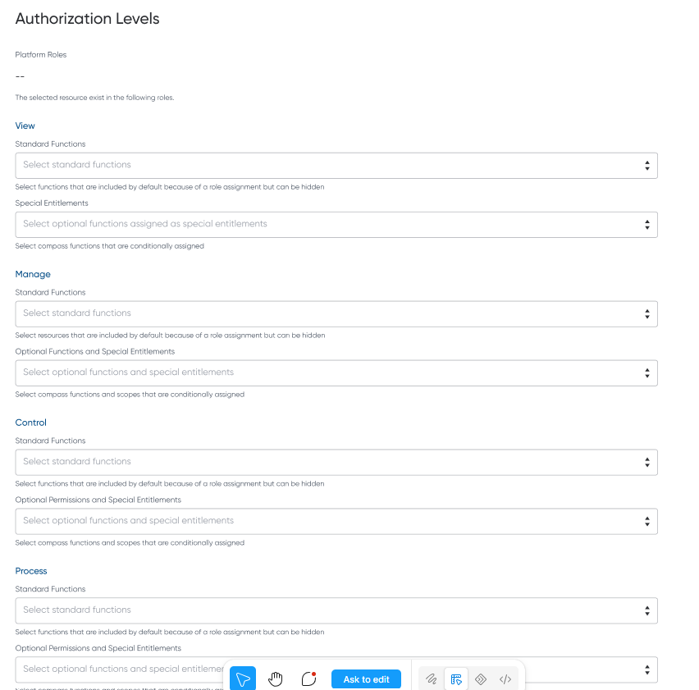
Feature name:
A Feature is a recognizable product offering, service, or functional area made available through Compass.
The feature is the central business object in the Feature Management directory. A feature belongs to one capability and may be delivered through one or more modules or integrated systems.
Examples:
Account Opening
Client and Account Inquiry
Orders
Systematic Plans
Transfer Management
CRS/FATCA Certification
The feature name is used wherever the feature is represented throughout the platform, including:
System-health status
Notification preferences
Field Summary
Label - Feature
Required
Type: 2 inputs
Placeholder 1: Feature name ( English )
Placeholder 2: Feature name ( French )
The Description of the feature, used internally only
Field Summary
Label - Description
Type: Text area
Placeholder: Feature Description
Capability:
A Capability is a high-level business domain that groups related Compass features.
A capability communicates the area of business activity supported by the platform and provides the primary grouping used in feature-access experiences.
Examples include:
Client Inquiry and Insights
Client Lifecycle Management
Client Servicing
Order Management
Trade Operations
Data and Reporting
User Access Management
The capability is not assigned directly to a user. Access is assigned through the packages and functions defined within its child features.
Field Summary
Label - Capability
Required
Type: Input
Placeholder: Feature’s Capability
Options:
Capability Reference Data
Each capability contains:
→ Capability ID: Unique identifier
→ Is Core: Indicates whether the capability is considered a core platform capability
→ Localized Name: Display name in the user's selected language
→ Localized Description: Description displayed in the user's selected language
Planned Feature management Use case:
The Feature Management function shall provide a common feature directory that can power the following platform services.
System health reporting
The system shall allow health events, incidents, degraded performance, outages, and planned maintenance to be associated with one or more registered modules.
The module is the health-reporting control point because it represents the user-recognizable entry point or major functional area within Compass. The existing system-health materials describe health events as being associated with affected Compass features and presented through a centralized status experience.
The directory shall provide:
The English and French name displayed in system-health messages.
The feature and capability context for the affected module.
The module lifecycle status.
The applicable system or integration.
A stable identifier that can be referenced by monitoring and incident-management services.
Notification subscription and delivery
The system shall allow notification topics and events from any integrated system to be associated with registered Compass capabilities, features, modules, and functions.
This association allows users to subscribe to notifications using Compass terminology even when the originating event is produced by another application.
For example:
Capability: Order Management
Feature: Orders
Module: Orders
Function: Manage Equity Orders
Event source: Trading system
Notification topic: Equity order rejected
Feature registration material identifies notifications, events, health checks, and system integrations as platform concerns that should reference the same stable feature definition rather than maintain separate representations.
Feature-access requests
The system shall provide the catalogue used to render feature-access options in user creation and modification requests.
Security Stewards shall see business-oriented capabilities, access levels, modules, and functions. The platform shall use the registry relationships to translate those selections into:
Compass module access.
Standard functions.
Elective functions.
Required system resources.
User access-package matching.
System-specific provisioning instructions.
The Unified Access Management materials describe capabilities, modules, and functions being presented at the View, Manage, Control, and Process levels, with applicable items filtered according to the selected level.
Manage firm Users – Externalized:
User Management Requests: Firm Security Steward Experience:
The User Management Dashboard provides Firm Security Stewards with a centralized view of all users within their firm, enabling them to effectively monitor user access, account status, and permissions before initiating any access management requests. The dashboard serves as the primary starting point for user administration activities, helping stewards make informed decisions by providing visibility into who has access to the platform, what functions they can perform, and the data they are authorized to view.
Through the dashboard, security stewards can search, filter, and review users across their organization, quickly identifying active, inactive, pending, suspended, or deactivated users. Each user profile presents a summarized view of key information such as role assignments, access profiles, feature entitlements, account affiliations, advisor or representative codes, and data access scopes. This visibility allows stewards to understand a user's current access posture and assess whether changes are required.
By providing immediate access to user status and access details, the dashboard reduces administrative effort, improves oversight, and supports compliance with firm access governance policies. Once a user has been reviewed, security stewards can initiate the appropriate request, such as creating a new user, modifying entitlements, updating account access, reactivating a user, or deactivating access, with confidence that they are acting on accurate and up-to-date information.
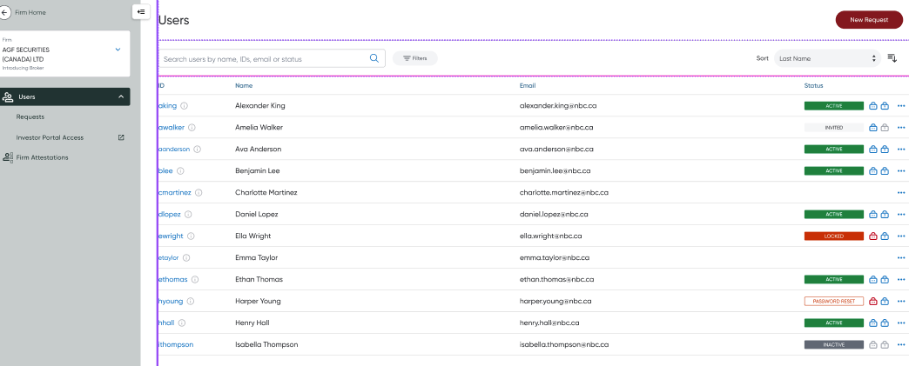
Status Column:
Module Title
Users

Total Items
# Users (total number of users available to the firm)

Columns
User ID → Unique system identifier associated with the user account.
Name → User's first and last name.
Email → Primary email address associated with the user account.
Status → Current user account status (e.g., Active, Invited, Locked, Password Reset, Inactive, Deactivated).
Password Status → Authentication password status represented by an icon indicator.
Security Question Status → Security question status represented by an icon indicator.
Actions → Contextual actions available for the selected user.

Column Sizes
User ID → 180 px
Name → Flex 1
Email → Flex 1
Status → 180 px
Actions → 80 px

Searchable Fields
no i18n fields searchable
User ID
First Name
Last Name
Full Name
Email Address

Sortable Fields
Last Name (Default)
First Name
User ID
Email
Status

Filterable Fields
User Status
Active
Invited
Locked
Password Reset Required
Inactive
Deactivated
Password Status
Not Set
Configured
Not Usable
Security Question Status
Not Set
Configured
Not Usable

Paging
Enabled: True

Default Page Size
50 users per page

User ID account association tooltip:
The User ID column provides Security Stewards with visibility into all platform accounts associated with a user without requiring navigation away from the User Management dashboard.

When a user has one or more associated platform accounts, hovering over the User ID value or information icon displays a tooltip containing a consolidated view of all account identifiers linked to the selected user.

This functionality allows Security Stewards to quickly validate account mappings across Compass and related applications when reviewing, updating, activating, or troubleshooting user access.

Primary user ID
The primary user id in the compass format is displayed as the value in the users table.

User ID info icon and tooltip
If there are more than one account, associated with the account then show the info icon and tooltip to showcase a list of the accounts a user has inside compass.

Tooltip
The primary user ID is the first user ID highlighted at the top of the tooltip and should be the same value as displayed in the cell. List the accounts this user holds, labelled by the name of the system and the value is the user ID of that application.
User Actions:
The User Management context menu provides Security Stewards with a set of actions that can be performed against an existing user record. The actions displayed and enabled within the menu are determined by the user's Compass account status to prevent invalid requests and guide Security Stewards toward appropriate account management workflows.

The context menu is accessed from the user record row within the User Management dashboard using the overflow (⋯) action menu.

Update User: Allows the Security Steward to submit a request to modify an existing user's profile, access, or account attributes.
Behavior
Selecting Update User launches the Update User Request workflow.
The selected user's identity information and existing profile configuration are pre-populated within the request.
Security Stewards can review and modify:
User details
RR information (where applicable)
Access profiles
Feature access
Data access permissions
Account settings

Reset Password: Allows a Security Steward to initiate a password reset for a user's Compass account.
Behavior
Selecting Reset Password submits a password reset request.
A temporary password is generated and communicated through the established credential delivery process.
The user is required to create a new password upon next login.

Reset Mobile MFA: Allows a Security Steward to reset a user's mobile multi-factor authentication registration.
Behavior
Selecting Reset Mobile MFA removes the user's existing MFA device registration.
The user must re-enroll a mobile authenticator during their next login.

Deactivate User: Allows a Security Steward to request the removal of a user's access to Compass.
Behavior
Selecting Deactivate User launches a confirmation dialog.
Upon confirmation, a deactivation request is submitted.
When processed, the user's account is marked inactive and access to Compass is revoked.

Activate User: Allows a Security Steward to restore access for an inactive Compass user.
Behavior
Selecting Activate User launches an activation request.
The Security Steward may review and optionally update the user's access profile prior to submission.
Once approved and processed, the user's Compass account returns to an active state.

Active Compass Account
Available actions:
Update User
Reset Password
Reset Mobile MFA
Deactivate User

No Compass Account
Available actions:
Update User
Note: Password, MFA, activation, and deactivation actions are not displayed because no Compass account exists.

Inactive Compass Account
Available actions:
Activate User
Note: Profile updates, password resets, MFA resets, and deactivation actions are unavailable until the account has been reactivated.
The User Authentication Profile Status indicator provides Security Stewards and Operations users with an at-a-glance view of whether a Compass user has completed the authentication credentials required to access the platform. The indicator displays the status of the user's password and security questions independently, helping administrators quickly identify users who may require credential setup, reset, or remediation before they can successfully log in.
Password
Security Question
---------
Muted (Grey) → Status: Not Configured
Description The authentication credential has not yet been established for the user.
Active (Blue) → Status: Configured
Description The authentication credential has been successfully configured and is available for use.
Error (Red) → Status: Not Usable
Description The authentication credential exists but cannot currently be used for authentication or recovery purposes.
Compass X User Lifecycle:
The Compass User Lifecycle defines the possible states of a Compass user account and the events that transition a user between those states. The lifecycle provides Security Stewards and internal operations teams with visibility into a user's current status while ensuring account access is managed in a secure and controlled manner.
A Compass user may transition through the following states:
Invited
First Sign In
Active
Locked
Password Reset
Inactive
Invited: The user account has been created and provisioned within Compass, but the user has not yet accessed the platform. The user receives account credentials and activation instructions but does not yet have an active login session.
Entry Conditions: A user enters the Invited state when:
A Create User request is approved and completed.
A new Compass account is provisioned.
Credentials are generated and issued.
Exit Conditions: The user exits the Invited state when:
The user successfully signs in for the first time.
The account is deactivated prior to first login.
Available Actions:
Resend credentials
Reset password
Deactivate user
First Sign In: The user has successfully authenticated for the first time and must complete initial account setup activities. These activities may include:
Accepting terms and conditions
Creating a permanent password
Registering mobile MFA
Establishing security preferences
Entry Conditions
User successfully signs in using temporary credentials.
Exit Conditions: The onboarding process is completed.
Available Actions:
Complete MFA enrolment
Create permanent password
Finish onboarding requirements
Active: The user has a fully provisioned Compass account and can successfully authenticate and access their authorized functionality. This is the standard operating state for Compass users.
Entry Conditions: A user becomes Active when:
Initial onboarding is completed.
An inactive account is successfully reactivated.
A locked account is successfully unlocked through password recovery.
Exit Conditions: The user may leave the Active state when:
The account becomes locked.
The user requests a password reset.
The account is deactivated.
Available Actions:
Update User
Reset Password
Reset Mobile MFA
Deactivate User
Locked: The account has been temporarily restricted due to security controls preventing user authentication. A locked account retains its assigned access and profile configuration but cannot be used to log in.
Entry Conditions: A user enters the Locked state when:
The maximum allowed failed login attempts is exceeded.
A security event triggers an account lock.
Exit Conditions: The lock condition is resolved.
Available Actions
Reset Password
Reset Mobile MFA
Deactivate User
Password Reset: A password reset process has been initiated and a temporary credential has been generated. The user must establish a new password before regaining normal access.
Entry Conditions: A Security Steward or support team initiates a password reset for an active or locked user.
Exit Conditions: The password reset process is completed.
Available Actions:
Complete password reset
Resend temporary credentials
Deactivate User
Inactive: The Compass account has been deactivated and is no longer able to authenticate or access platform functionality. User profile information, audit history, and account associations remain retained for compliance and operational purposes.
Entry Conditions: An approved deactivation request is completed.
Exit Conditions: A Security Steward submits an activation request and the account is re-enabled.
Available Actions:
Activate User
Restricted Actions:
The following actions are unavailable while a user is inactive:
Update User
Reset Password
Reset Mobile MFA
Deactivate User
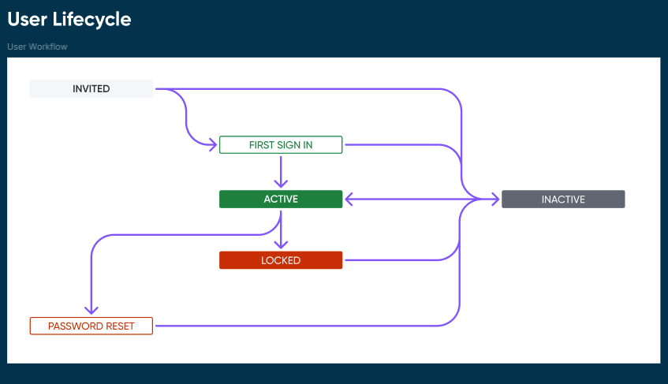
View user profile- modal:
The User Profile Modal provides Firm Security Stewards with a comprehensive, read-only view of a user's profile, account credentials, data access, and application feature entitlements. The modal serves as a centralized reference point that enables Security Stewards to understand a user's identity, account configuration, access scope, and operational capabilities before submitting a change, deactivation, reactivation, or access-related request. By presenting all relevant user information in a structured and easily scannable format, the modal reduces the need to navigate across multiple systems and helps stewards make informed access management decisions.
The modal is launched from the User Management Dashboard and displays detailed information for a selected user within an overlay, allowing the Security Steward to review access without leaving the current page. Information is organized into logical sections including User Information, Accounts, Data Access, and Feature Access. User details provide visibility into profile attributes such as name, email address, and language preferences. The Accounts section presents system-specific account identifiers and provides contextual administrative actions, such as password reset or multi-factor authentication reset, for authorized users.
The Data Access section provides visibility into the user's assigned access scope and associated representative, advisor, or IA codes, enabling Security Stewards to understand the client and account data the user is authorized to access. Where applicable, tools are provided to easily copy assigned codes for audit, review, or request preparation purposes.
The Feature Access section offers a detailed breakdown of the user's permissions across platform modules and business capabilities. Each capability area displays the user's assigned role level (such as View, Manage, or Control), associated features, and any optional permissions or special entitlements granted within that module. This allows Security Stewards to quickly identify the exact functionality available to the user and determine whether modifications are required.
The modal is intended to support oversight, auditing, and access governance activities by providing complete visibility into a user's current access configuration while preventing direct edits to production access. Any required changes identified during review must be initiated through the appropriate user management workflow, ensuring that all access modifications remain governed by approval and fulfillment processes.
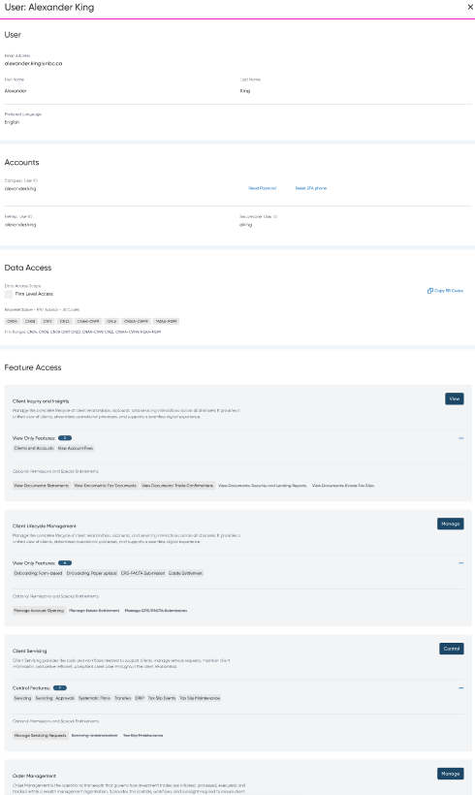
New Request: Update User
The Update User Request experience enables Security Stewards to submit changes to an existing user profile on behalf of individuals within their firm. The request form provides a structured way to identify the user, specify the required changes, and submit the request for processing by the ID Administration team.
Security Stewards can request updates to a user's representative assignments and data access scope, including RR codes, advisor codes, branch affiliations, and the accounts or client data the user is authorized to access. The experience also supports changes to feature entitlements and platform capabilities, allowing firms to grant or remove access to specific Compass modules, functions, and permissions based on the user's responsibilities.
In less frequent scenarios, Security Stewards may also submit requests to update user profile information, such as name, email address, language preferences, or other identity-related attributes when business or organizational changes occur.
Once submitted, the request enters the standard review and fulfillment workflow, where progress and outcomes can be tracked through the Requests dashboard.
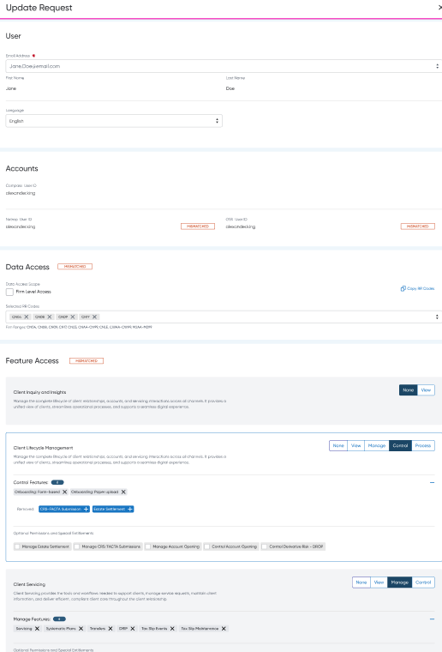
Updating Deactivated User:
If the selected user has been deactivated, profile update requests cannot be submitted because no changes can be made to an inactive user account.
To make changes for this individual, submit a New User Request to reactivate the user and assign the appropriate access profile, including the required data access, feature entitlements, and permissions. Once the user has been reactivated and provisioned with the desired access profile, future changes can be managed through the standard user update process.
New Request: Deactivate User
The Deactivate User Request experience enables Security Stewards to initiate the removal of a user's access across Compass technology offerings when the individual no longer requires access to firm systems. This may occur when a user leaves the organization, changes roles, takes an extended leave of absence, or no longer requires access to specific business functions.
The request captures the user to be deactivated and submits the request for processing by the ID Administration team. Once fulfilled, the user's access to Compass applications, feature entitlements, and associated permissions is removed in accordance with firm access management policies. The request then follows the standard review, processing, and outcome communication workflow, providing visibility into the status and final disposition of the request.

Manage requests:
User Management Requests: Firm Security Steward Experience:
This module enables Security Stewards to submit and manage user administration requests for their firm while ensuring strict firm-level segregation of data and access. Security Stewards can view and track only the requests associated with firms in which they are enrolled. After submitting a request, they can monitor its progress through the full lifecycle, from submission to completion, and may cancel the request at any time before it has been accepted for processing. Once the request is completed, the module provides a clear outcome indicating whether the requested changes were successfully applied as submitted or, if unsuccessful, the reasons for any discrepancies, errors, or rejected actions, allowing Security Stewards to validate the results and take any necessary follow-up actions.
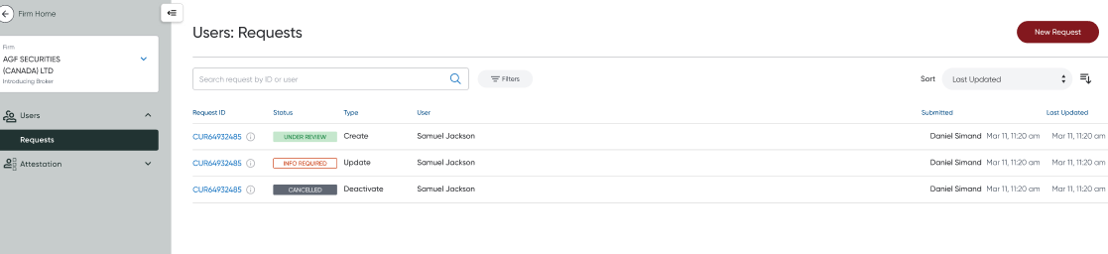
User Management Requests Module Configuration:
Module title: Users: Requests

Total Items: # Requests Columns:
Request ID → System generated ID with prefix CUR for Compass User Request
Status → Feature Status
Request Type → Current types include: Create, Update, Deactivate
User → The user for which the request is for
Submitted → The user and time the request was submitted
Last Updated → The last update of any kind on the request

Searchable fields
Request ID
User’s name ( First and Last )
User’s email
User’s user id

Sortable fields
Last updated ( Default )
Submitted
User ( Last name )
Request ID

Filterable fields
Status
Type
Firm
Submitted
Last Modified

Column Size:
Request ID → 340 px
Status → 140 px
Type → 140 px
User → Scale ( Flex 1 )
Submitted → 600 px
Last Updated → 340 px

Paging: True
Request lifecycle:
Submitting... - the moment the request in submitted
Submitted - the moment the system confirms receipt of the request
Cancelled - [terminal state] only available in submitted status, before the request is made to under review. This status is applied when the system acknowledges that the request was cancelled successfully. If the cancel fails, the request will remain in submitted status.
Under review - the moment the request processor starts the request
Rejected - [terminal state] only available in the under review status. The processor can reject a requests and communicate the reason so that the requestor can submit a new corrected request.
Complete - [terminal state] the moment the processor confirms the request is complete
New Request: Create User:
The Create User Request feature enables Security Stewards to submit requests for new users within their firm by defining the user's identity information, establishing default preferences, assigning feature access permissions, and configuring data access entitlements. The request provides a structured workflow for provisioning users with the appropriate level of access based on their role and responsibilities, while ensuring all requested settings can be reviewed, tracked, and validated through completion.
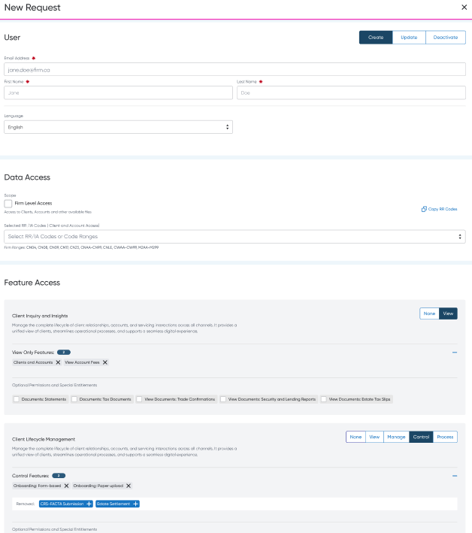
Type Toggle:
Toggle: https://www.figma.com/design/EzY51epDvmPJ7VtJC5Esbx/Compass-Design-System?node-id=8301-2591
Size: Normal
Length: Medium
Options:
Create
Update
Deactivate
Client And Account AccesS:
The Client and Account Access component allows Security Stewards to define the client and account data a user is authorized to access within the firm. Access can be assigned at either the firm level or through a specific set of RR/IA Codes, enabling firms to align data visibility with a user's business responsibilities.

The component supports both broad access assignments for users who require visibility across the entire firm and targeted access assignments for users who should only access clients and accounts associated with designated RR/IA Codes.

Firm Level Access
Control Type: Checkbox
When selected:
Grants the user access to all clients and accounts within the firm.
Applies access across all RR/IA Codes associated with the firm.
The firm ranges displayed below are provided for informational purposes only.
RR/IA Code selection is disabled and not required.
When deselected:
Access must be granted by assigning one or more RR/IA Codes.
The user will only have access to clients and accounts associated with the selected codes.

Selected RR / IA Codes
Control Type: Multi-select input
Used to define the RR/IA Codes that determine the user's client and account access scope.

Supported Behaviours
Users may:
Select one or more RR/IA Codes from available options.
Select code ranges where supported.
Paste a comma-separated list of RR/IA Codes.
Remove individual codes from the selection.
Clear all selected values.
Copy the selected values to the clipboard using the Copy RR Codes action.
Upon paste:
Each valid RR/IA Code is parsed and added as an individual selection.
Duplicate values are automatically removed.
Invalid codes are rejected and surfaced to the user.

Copy RR Codes
Selecting Copy RR Codes:
Copies all currently selected RR/IA Codes to the clipboard.
Preserves comma-separated formatting.
Displays a success confirmation message.

Clear Selection
Users may:
Remove individual RR/IA Codes.
Clear all selected values in a single action.
Feature Access:
The Feature Access section renders the capabilities, modules, and functions available to a user based on the resources assigned to the selected firm. The experience presents capabilities as business-oriented groupings of system functionality and allows users to review or assign access only to resources that are available to that firm.
Capabilities, modules, and functions are sourced from centralized reference data and filtered using the firm's assigned resource set before rendering.
Capability Reference Data
Each capability contains:
Capability ID: Unique identifier
Display Order: Numeric value controlling rendering order
Is Core: Indicates whether the capability is considered a core platform capability
Localized Name: Display name in the user's selected language
Localized Description: Description displayed in the user's selected language
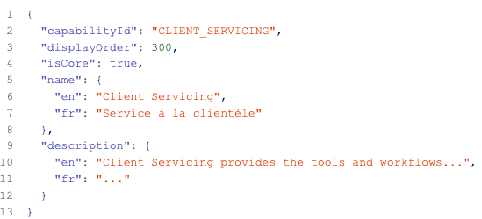
Firm Resource Filtering
Before rendering the capability list, the system must determine which resources are licensed and available to the selected firm.
The filtering process begins by retrieving the complete set of resources assigned to the firm. These resources represent the modules and functions that the firm is entitled to use.
After the firm's resources have been identified:
Any module that is not included in the firm's resource assignments must be excluded.
Any functions associated with an excluded module must also be excluded.
Functions that are not individually assigned to the firm must also be excluded, even if their parent module remains available.
The resulting view contains only the modules and functions that are available to that specific firm.
This ensures that administrators only see capabilities and features that can actually be assigned to users within the firm.
Capability Visibility Rules
A capability should only be displayed when it contains at least one module that remains available after firm filtering has been applied.
If all modules within a capability have been removed during filtering, the capability should not be displayed.
This prevents empty capabilities from appearing in the interface and ensures the experience remains relevant to the selected firm's product entitlements.
Example
A firm may not subscribe to any resources associated with Trading Tools.
In this scenario:
All Trading Tools modules are removed.
Any functions associated with those modules are removed.
The Trading Tools capability is hidden entirely.
Conversely, if even a single module remains available, the capability should continue to be displayed.
Capability Ordering
Capabilities must always appear in the order defined by the capability reference data.
The configured order is independent of:
User access
Firm resources
Capability popularity
Recent activity
Rendering order must remain consistent across all firms to provide a predictable user experience.
Core Capability Indicator
Certain capabilities are designated as Core capabilities.
Core capabilities are grouped together at the beginning of the form proceeded by a separator and then the remaining capabilities are listed.
Supporting SSO Firms:
To support firms that authenticate users through their own enterprise identity provider and automatically launch Compass using Single Sign-On (SSO), Compass requires a unique external identifier to associate the incoming authentication request with the correct Compass user profile.
When creating or updating a Compass user who will access the platform through SSO, Security Stewards must provide an SSO User ID. This value represents the unique user identifier supplied by the firm's enterprise identity management system and is used by Compass during the authentication process to identify and sign in the appropriate user account.
SSO User ID
The SSO User ID is required for users expected to access Compass through SSO.
The value must exactly match the identifier transmitted by the firm's identity provider during authentication.
Input
Required
Show for firms with external IDP and SSO. When IDP Source is not CXP
New Request: Update User:
The Update User Request experience enables Security Stewards to submit changes to an existing user profile on behalf of individuals within their firm. The request form provides a structured way to identify the user, specify the required changes, and submit the request for processing by the ID Administration team.
Security Stewards can request updates to a user's representative assignments and data access scope, including RR codes, advisor codes, branch affiliations, and the accounts or client data the user is authorized to access. The experience also supports changes to feature entitlements and platform capabilities, allowing firms to grant or remove access to specific Compass modules, functions, and permissions based on the user's responsibilities.
In less frequent scenarios, Security Stewards may also submit requests to update user profile information, such as name, email address, language preferences, or other identity-related attributes when business or organizational changes occur.
Once submitted, the request enters the standard review and fulfillment workflow, where progress and outcomes can be tracked through the Requests dashboard.
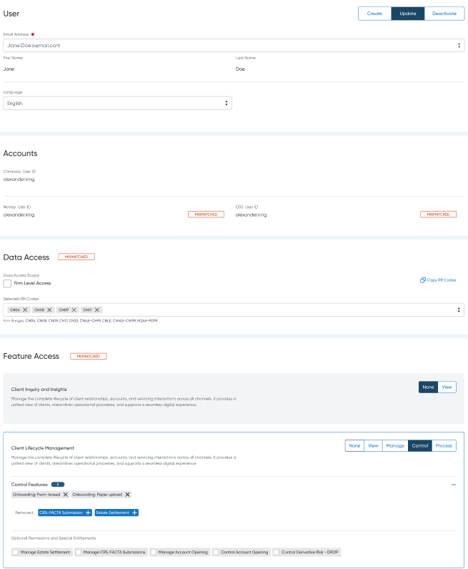
Updating Deactivated User:
If the selected user has been deactivated, profile update requests cannot be submitted because no changes can be made to an inactive user account.
To make changes for this individual, submit a New User Request to reactivate the user and assign the appropriate access profile, including the required data access, feature entitlements, and permissions. Once the user has been reactivated and provisioned with the desired access profile, future changes can be managed through the standard user update process.
New Request: Deactivate User:
The Deactivate User Request experience enables Security Stewards to initiate the removal of a user's access across Compass technology offerings when the individual no longer requires access to firm systems. This may occur when a user leaves the organization, changes roles, takes an extended leave of absence, or no longer requires access to specific business functions.

The request captures the user to be deactivated and submits the request for processing by the ID Administration team. Once fulfilled, the user's access to Compass applications, feature entitlements, and associated permissions is removed in accordance with firm access management policies. The request then follows the standard review, processing, and outcome communication workflow, providing visibility into the status and final disposition of the request.
SSA / ID Admin Team Experience:
User Management Requests Module Configuration:
Module title: Users: Requests
Total Items: # Requests Columns:
Request ID → System generated ID with prefix CUR for Compass User Request
Status → Feature Status
Request Type → Current types include: Create, Update, Deactivate
Firm → Only visible to parent firm users or LOB, Displayed in the same format as the firm switcher
User → The user for which the request is for
Submitted → The user and time the request was submitted
Response → Time between submitted and started, -- if not started yet
Resolution → Time between submitted and completed, -- if not completed
Last Modified → The last modified user and timestamp
Searchable fields
Request ID
User’s name ( First and Last )
User’s email
User’s user id
Sortable fields
Last Modified ( Default )
Submitted
User ( Last name )
Request ID
Filterable fields
Status
Type
Firm
Submitted
Last Modified
Column Size:
Request ID → 340 px
Status → 140 px
Type → 140 px
Firm → Scale ( Flex 1 )
User → Scale ( Flex 1 )
Submitted → 600 px
Last Modified → 340 px
Paging: True
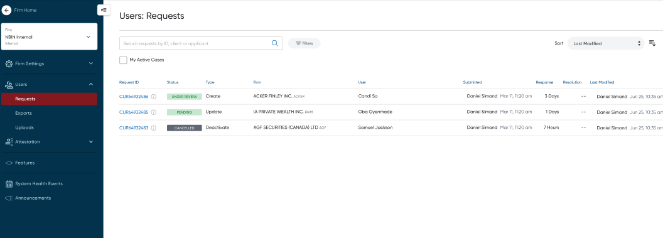
Request Review and Intake:
The Request Review experience enables processors to evaluate incoming user management requests before work begins. Processors can review the request details, including firm information, user profile data, requested data access, and feature entitlements, to determine whether the request is complete, valid, and eligible for processing.
Based on the review, processors can either Start Request to move the request into the Under Review state and begin fulfillment activities, or Reject the request when required information is missing, the request does not meet policy requirements, or the requested changes cannot be processed. This intake step helps ensure that only valid and actionable requests enter the processing queue, improving operational efficiency and maintaining access governance standards across the Compass platform.
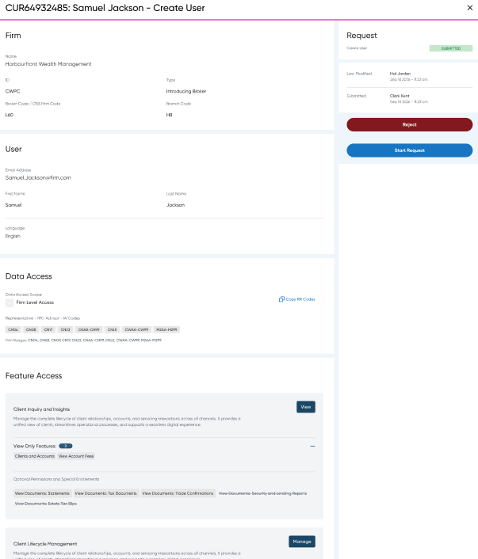
View Requests – Processor:
Start Request
This action will start the request and communicate to the requestor that the request is now under review.
Because this action is irreversible, a confirmation step is required to prevent accidental processing of a request.
Confirmation Dialog
Title: Sure you want to start this request?
Description:
This cannot be undone.
This will communicate to the submitter that the request is under review.
Actions
Cancel
Stops the action and returns to the previous state.
Start Request
If successful
Move the request to Under Review.
Record the start date and status change in the request history.
Notify the requestor that the request has entered review.
Trigger a toast notification:
Type: Success
Message: Request <Request ID> started successfully.
Refresh the modal to display the updated request status.
If failed
The action may fail if:
The request was cancelled before the action was processed.
The request was rejected by another administrator before the action was processed.
The request was already started or completed by another administrator.
A system or technical error occurred.
In these cases:
Trigger a toast notification:
Type: Error
Message: System error while starting request <Request ID>.
The request remains in its previous state.
Refresh the modal content to display the latest request status and details.
Reject Request:
This action will reject the request and communicate to the requestor that the request will not be processed.
This is an irreversible action, so it requires confirmation and a reason for rejection to ensure the requestor understands why the request was declined.
Confirmation Dialog
Title: Sure you want to reject this request?
Description:
This cannot be undone.
This will communicate to the submitter that the request has been rejected.
A rejection reason is required and will be shared with the submitter.
Fields
Rejection Reason (required)
Actions
Cancel
Stops the action and returns to the previous state.
Reject Request
If successful
Move the request to Rejected.
Store the rejection reason in the request history.
Trigger a toast notification:
Type: Success
Message: Request <Request ID> rejected successfully.
Refresh the modal to display the updated status and rejection details.
If failed
Could fail if the request was completed, cancelled, or rejected by another administrator before the action was processed.
Could fail for technical reasons.
In these cases:
Trigger a toast notification:
Type: Error
Message: System error while rejecting request <Request ID>.
The request remains in its previous state.
Refresh the modal content to display the latest request status.
Request Fulfillment and Resolution:
The Request Fulfillment experience enables the ID Administration team to process user management requests that have been accepted for review. During this stage, processors perform the requested user administration activities, such as creating users, updating profiles, assigning feature entitlements, configuring data access, and validating that all required access changes have been completed.
Once processing is complete, the processor can either Complete the Request to confirm successful fulfillment or Reject the Request if the request cannot be completed due to validation issues, policy restrictions, missing information, or other processing constraints. In both cases, the outcome is recorded in the request history and communicated to the requestor, ensuring transparency and a complete audit trail.
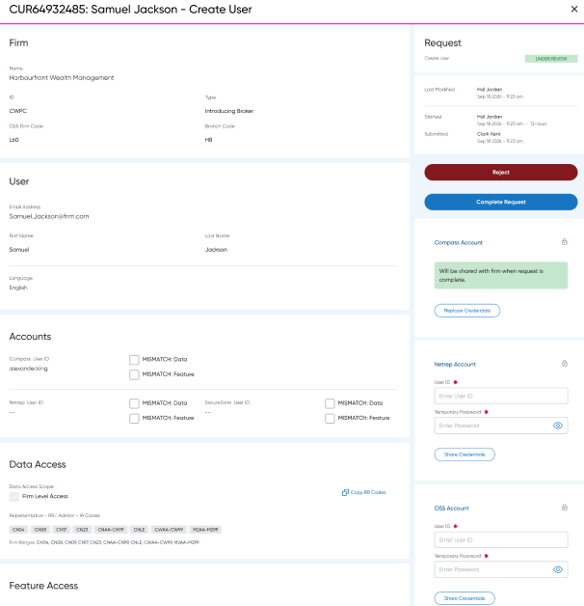
Processing the Request:
When the request is under review and the user has the process user requests resource their task is to fulfil the request and communicate the result.
The options available at this time include:
Rejecting the request
Completing the request
Reject Request”
This action will reject the request and communicate to the requestor that the request will not be processed.
This is an irreversible action, so it requires confirmation and a reason for rejection to ensure the requestor understands why the request was declined.
Confirmation Dialog
Title: Sure you want to reject this request?
Description:
This cannot be undone.
This will communicate to the submitter that the request has been rejected.
A rejection reason is required and will be shared with the submitter.
Fields
Rejection Reason (required)
Actions
Cancel
Stops the action and returns to the previous state.
Reject Request
If successful
Move the request to Rejected.
Store the rejection reason in the request history.
Trigger a toast notification:
Type: Success
Message: Request <Request ID> rejected successfully.
Refresh the modal to display the updated status and rejection details.
If failed
Could fail if the request was completed, cancelled, or rejected by another administrator before the action was processed.
Could fail for technical reasons.
In these cases:
Trigger a toast notification:
Type: Error
Message: System error while rejecting request <Request ID>.
The request remains in its previous state.
Refresh the modal content to display the latest request status.
Complete Request:
This action will complete the request and communicate the outcome to the requestor.
A completion outcome must be provided to indicate whether the request was completed successfully, completed with exceptions, or could not be completed. Any discrepancies or failures should be documented so the requestor can understand the final result.
Confirmation Dialog
Title: Sure you want to complete this request?
Description:
This cannot be undone.
This will communicate the final outcome of the request to the submitter.
Completion details will be visible to the submitter.
Fields
Outcome Status (required)
Completed Successfully
Completed with Exceptions
Unable to Complete
Completion Notes (required)
Actions
Cancel
Stops the action and returns to the previous state.
Complete Request
If successful
Move the request to Completed.
Store the outcome status and completion notes in the request history.
Notify the requestor of the final outcome.
Trigger a toast notification:
Type: Success
Message: Request <Request ID> completed successfully.
Refresh the modal to display the updated status and completion details.
If failed
Could fail if the request was cancelled, rejected, or completed by another administrator before the action was processed.
Could fail for technical reasons.
In these cases:
Trigger a toast notification:
Type: Error
Message: System error while completing request <Request ID>.
The request remains in its previous state.
Refresh the modal content to display the latest request status.
Generating Account Credentials Instructions:
Per System Instructions
Current system profile:
Get the users current assignments per system ( new user has none )
Requested system profile:
Generate requested assignments per system
Compare current and requested system assignment
No existing functions in a system:
Check the system authentication type
External
Create user and share credentials
Hybrid
Is this current firm setup as an external IDP/SSO
Yes → Create users and DO NOT share credentials, link account if needed
No → Create user and share credentials
No new functions in a system:
Deactivate the user in that system
Sharing Account Credentials with Firm Security Steward:
The Compass Account section allows the internal ID Administration team to securely provide Compass account credentials to the firm's designated Security Steward as part of a user onboarding or access request fulfillment process. The component progresses through three states:
Credentials Pending Entry
Credentials Scheduled for Sharing
Credentials Shared
Credentials are only visible to authorized internal administrators and are never exposed directly to the submitted request record after sharing.
Credentials Pending Entry
This state is displayed when the request has reached the fulfillment stage and the internal ID Administration team must provide Compass account credentials before the request can be completed.
User ID: Required text field used to enter the User ID assigned to the user.
Temporary Password: Required password field used to enter a temporary password generated for the user.
Share Credentials Button: Primary action used to submit the credentials for delivery to the firm's Security Steward.
Security IconIndicates that the information entered is considered sensitive and is subject to secure handling procedures.
Credentials Scheduled for Sharing
This state indicates that credentials have been entered by the ID Administration team and will be delivered to the firm's Security Steward when the access request reaches a completed status.
Information Banner: Displays the message: "Will be shared with firm when request is complete."
Replace Credentials Button: Allows the administrator to replace previously entered credentials prior to request completion.
Replace Credentials:
The Replace Credentials action allows the Internal ID Administration team to remove previously entered Compass credentials that are scheduled to be shared with the firm's Security Steward and replace them with a new User ID and/or Temporary Password before the request is completed.
This action is intended for situations where credentials were entered incorrectly, a temporary password has expired, a new account has been provisioned, or the administrator determines that previously submitted credentials should no longer be used.
Completed Request:
The Request Fulfillment experience enables the ID Administration team to process user management requests that have been accepted for review. During this stage, processors perform the requested user administration activities, such as creating users, updating profiles, assigning feature entitlements, configuring data access, and validating that all required access changes have been completed.
Once processing is complete, the processor can either Complete the Request to confirm successful fulfillment or Reject the Request if the request cannot be completed due to validation issues, policy restrictions, missing information, or other processing constraints. In both cases, the outcome is recorded in the request history and communicated to the requestor, ensuring transparency and a complete audit trail.
Request Monitoring and Status Tracking:
The Requests workspace enables Security Stewards to monitor all user management requests submitted on behalf of users within their firm. Through a centralized request dashboard, Security Stewards can track newly submitted requests, monitor requests approaching service level targets, and stay informed of any updates throughout the request lifecycle.
The dashboard provides visibility into the current status of each request, including Submitted, Under Review, Information Required, Completed, Rejected, and Cancelled, allowing Security Stewards to quickly identify requests that require attention or follow-up. Request details, submission dates, and last updated timestamps help users understand progress and prioritize outstanding items.
When a request status changes, such as when additional information is required, processing is completed, or a request is rejected, the updated status is surfaced within the request list, providing a transparent view into the outcome and current disposition of all submitted requests.
Benefit: Gives Security Stewards a single place to track the progress of user access requests, proactively monitor SLA performance, respond to information requests, and maintain visibility into all user administration activities occurring within their firm.
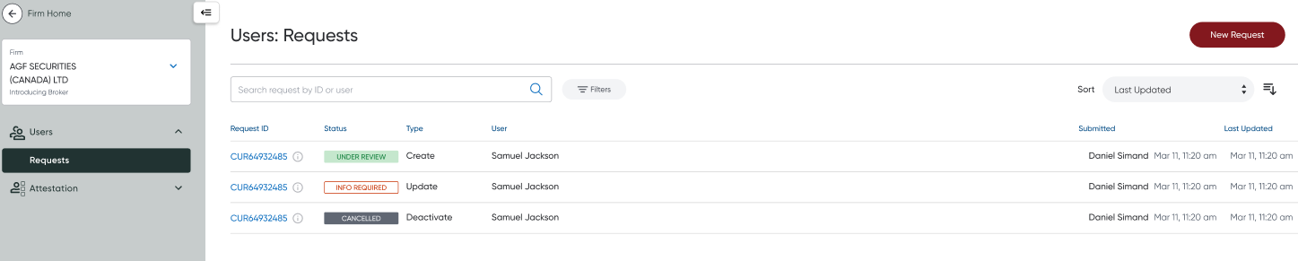
View submitted request – Submitted:
The Request Details experience allows Security Stewards to view a complete, read-only record of any user management request submitted on behalf of their firm's users. The detailed view provides full visibility into the request, including user information, requested profile changes, data access assignments, feature entitlements, request status, submission history, processing updates, and final outcomes.
While requests cannot be modified after submission, Security Stewards may cancel a request that is no longer required, provided it has not already been completed or otherwise reached a terminal state. Cancelling a request immediately stops further processing and communicates the cancellation to the processing team.
View submitted request - Under Review:
The Request Details experience allows Security Stewards to view a complete, read-only record of a submitted user management request while it is being processed by the ID Administration team. The detailed view provides visibility into all request information, including user details, requested profile changes, data access assignments, feature entitlements, submission history, and the current processing status.
When a request reaches the Under Review status, the request is actively being worked on by the processing team and can no longer be cancelled by the Security Steward. At this stage, the Security Steward's role is to monitor progress and remain informed of any updates communicated by the processing team.
The request details view highlights the current status, processing milestones, and recent activity, allowing the Security Steward to track requests that are approaching service level targets, identify when additional information is required, and view the final outcome once processing has been completed or the request has been rejected.
View submitted request – Complete
The Request Details experience allows Security Stewards to view a complete, read-only record of a user management request that could not be processed by the ID Administration team. The detailed view provides visibility into the original request, including user information, requested profile changes, data access assignments, feature entitlements, processing history, and the final disposition of the request.
When a request reaches the Rejected status, processing has been stopped and no changes have been made to the user's profile or access. Security Stewards can review the rejection details, including the reason the request could not be fulfilled and any guidance provided by the processing team to help resolve the issue. Common reasons may include missing information, insufficient authorization, policy restrictions, invalid request details, or unsupported access requests.
The rejected request remains available for reference and audit purposes, allowing Security Stewards to understand the outcome, determine whether corrective action is required, and submit a new request if necessary.

